
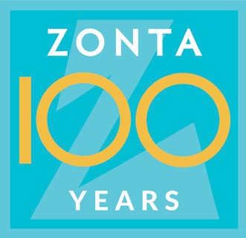
PO Box 389
Lockport, New York 14095-0389
Email: ZontaClubOfLockport@yahoo.com
Website: ZontaClubOfLockport.com

Fall Fundraiser Donation Form

ADVERTISING OPTIONS

Name/Business Name: ___________________________________ (how you want name to show on website/Facebook)
Contact Name: ___________________________________
Contact Phone Number: ___________________________________
Contact Email Address: ___________________________________
Business Address: ___________________________________
City __________________________ State ____ Zip Code _________
Website or Facebook address: ___________________________________

If you are a Gold sponsor, please email your business card or logo to: ZontaClubOfLockport@yahoo.com

Please make check payable to: Zonta Club of Lockport, NY Inc.

Please complete the form below and mail with the check to:

Zonta Club of Lockport, NY Inc.
PO Box 389
Lockport, NY 14095

☐ | $ 100.00 | Gold Sponsor – Listing on both our Website & Facebook* page AND your business card/logo and with a link to your business website &/or Facebook page on our website.  **Please email your business card / business logo to: ZontaClubOfLockport@yahoo.com
☐ | $ 75.00 | Silver Sponsor – Listing on both our Website & Facebook* page with link to your business  website or Facebook page
☐ | $ 50.00 | Bronze Sponsor – Listing on our Website with a link to your business website or Facebook page
☐ | $ 30.00 | Patron Ad – Name listed on the Website ONLY

*Includes name listed on Facebook including “tagging” on the Zonta Club of Lockport’s Facebook page and
also a listing of your business with a link to your website/Facebook page on Zonta Club of Lockport’s website

Founded in 1919, Zonta International is a leading global organization of professionals
empowering women worldwide through service and advocacy.

