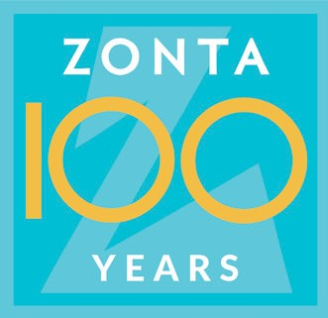
P. O. Box 389
Lockport, New York 14095-0389

Zonta Club of Lockport’s Privacy Policy & Publicity Authorization

The Zonta Club of Lockport New York, Inc. (hereinafter referred to as “Zonta Club”) is committed to honoring the privacy and wishes of all of our scholarship and award winners as well as our funding recipients at all times. In order to do this, please read the following carefully and indicate your agreement(s) as appropriate. Check all that apply.

- Data collected by the Zonta Club is used only to help better serve its recipients. It is our general policy to collect and store only personal information that our recipients knowingly provide. The Zonta Club does not sell, trade or rent your personally identifying information to third parties, except for forwarding scholarship information to apply to Zonta International and Zonta International Foundation scholarships and/or awards.

☐ I have read the above paragraph and agree to the Terms and Conditions therein

- To ensure the Zonta Club’s ability to fund scholarships and awards, the Zonta Club may use my photograph, quotes or excerpts of my written or verbally expressed words, my name, alias, or biographical information (hereinafter collectively referred to as “My Likeness”) to promote fundraising for our services, scholarships and/or awards.

I understand My Likeness may be copied, reproduced or distributed by means of various media, including, but not limited to: news releases, placement on websites and/or other electronic delivery, publication, display, or promotion on any and all other media, and I further understand that My Likeness may be subject to reasonable modification or editing. I waive any right to inspect or approve the finished product or material in which the Zonta Club may eventually use My Likeness.

☐ I have read the above paragraph and agree to the Terms and Conditions therein

I, the undersigned, permit and authorize the Zonta Club and its employees, agents, representatives, contractors, and personnel who are acting on behalf of the Zonta Club to create, obtain and/or use My Likeness and information, as related to the purposes agreed to above, without compensation to me.

This Authorization shall be binding upon my heirs, successors, assigns, and legal representations. I understand that I may not withdraw my permissions which were granted in this Authorization. I have read and understand the Terms and Conditions of these Authorizations.

____________________________________________________ ______________________
Signature Date

____________________________________________________
Printed Name
Print, sign and send the completed form:
By email to: ZontaClubOfLockport@yahoo.com
or
By mail to: Zonta Club of Lockport New York, Inc., PO Box 389, Lockport, NY 14095-0389

